Module Name: Login Page - Functional & UI Test Cases
Test Case ID:st_01
Environment:OS: Windows 11, Browser: Chrome, URL:https://www.amazon.com

- Scenario ID: 1a
- Scenario: Valid Login
Test step:
- Open Amazon website.
- Click Sign in
- Enter Valid registered
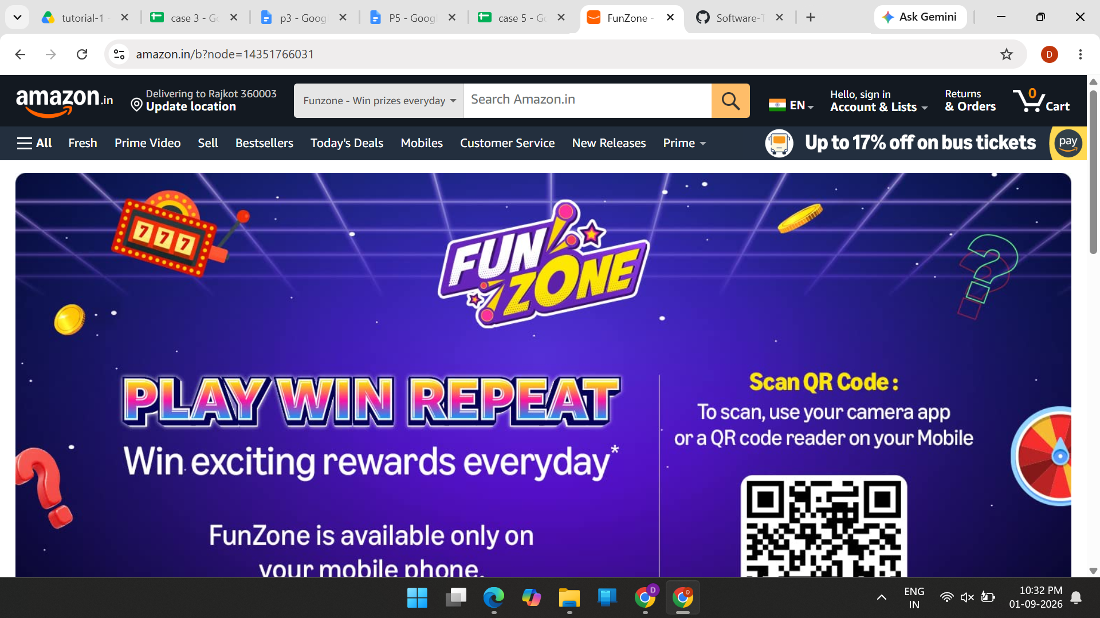

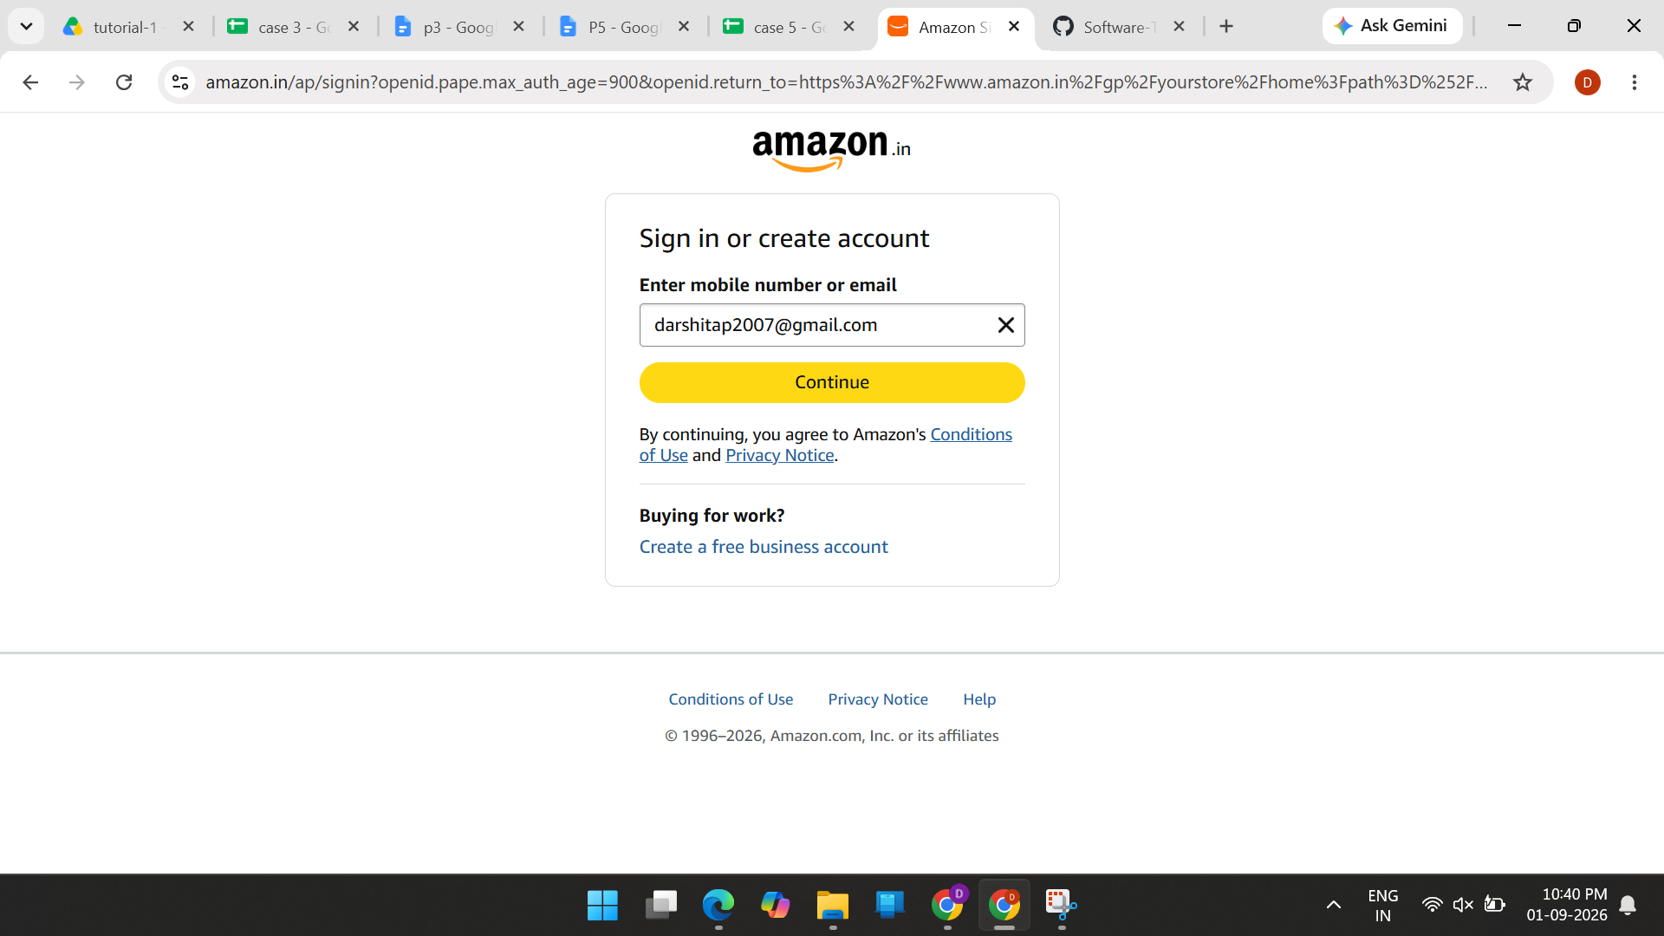

- Scenario ID: 1b
- Scenario: InValid Login
Test step:
- Open Amazon website.
- Click Sign in
- Enter Invalid registered

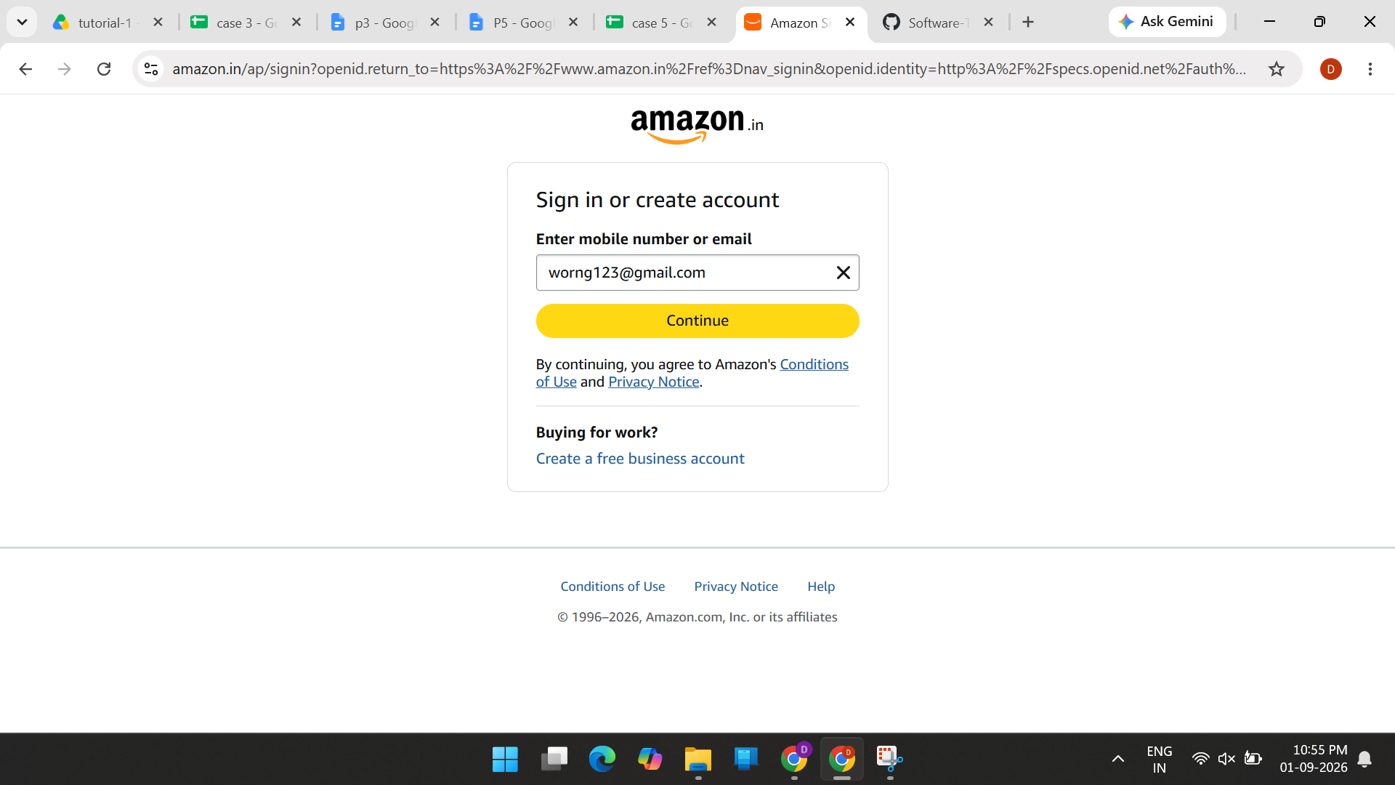

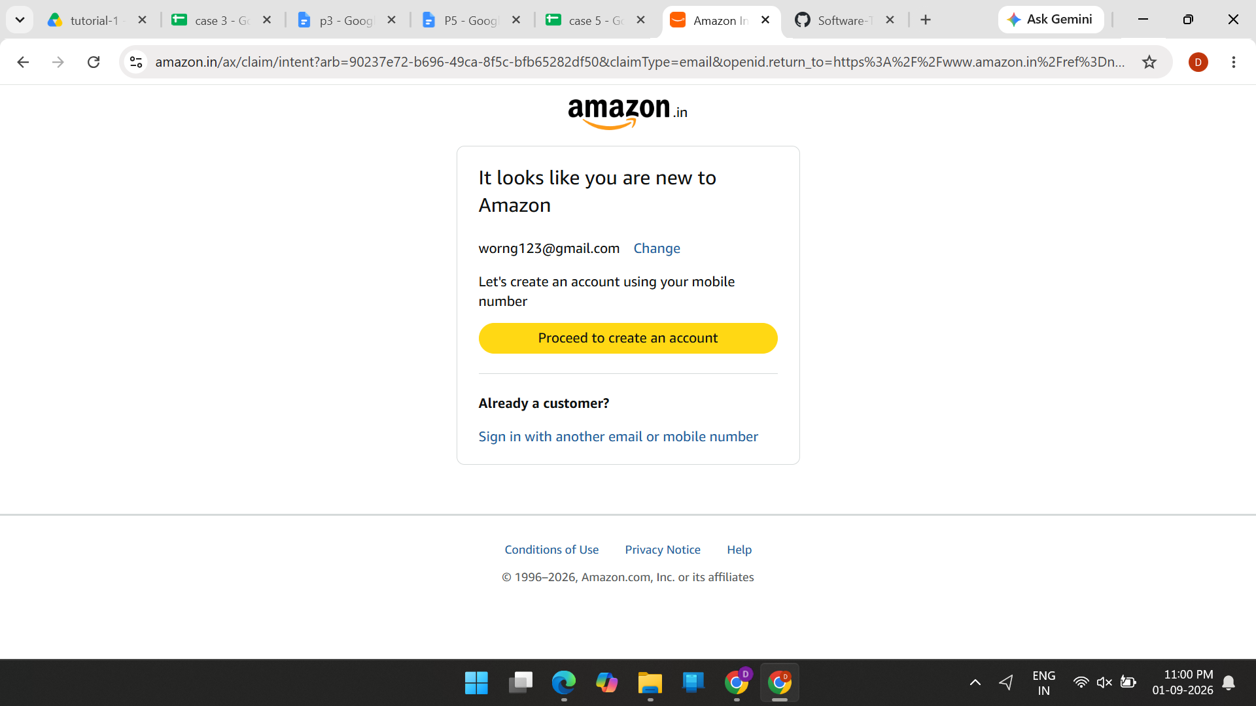

- Scenario ID: 1c
- Scenario: View products
Test step:
- Open Amazon website.
- Search for a product.
- Enter laptop in the search box.
- Click Search.
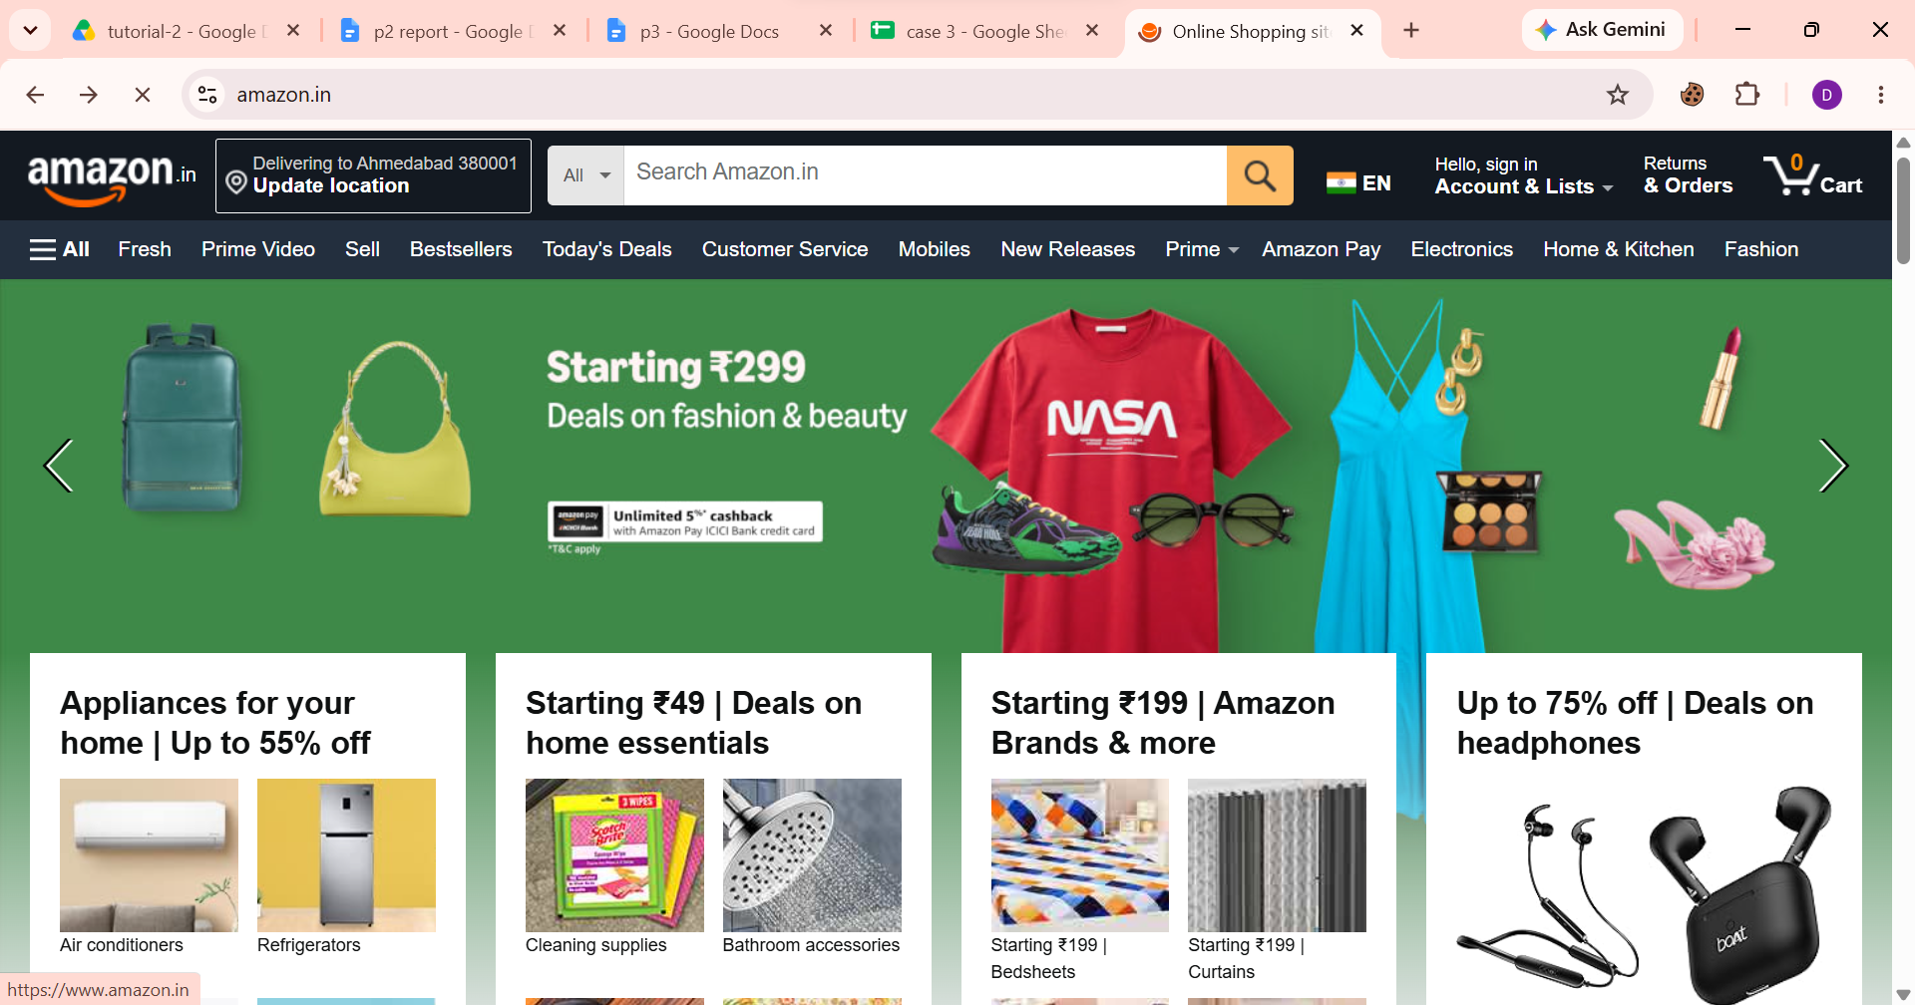
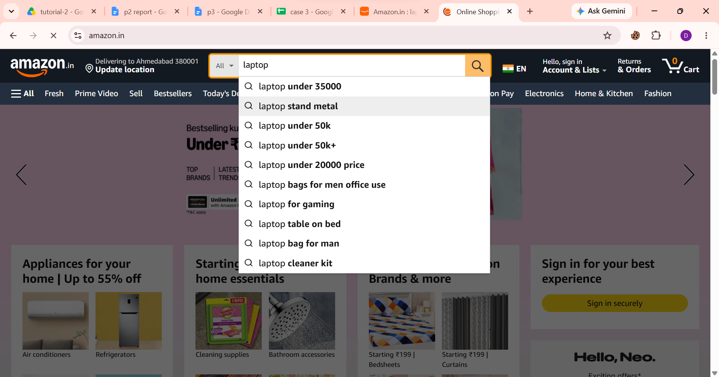

- Scenario ID: 1d
- Scenario: Select product
Test step:
- Open Amazon product listing.
- Select any available product.
- Click on the product.
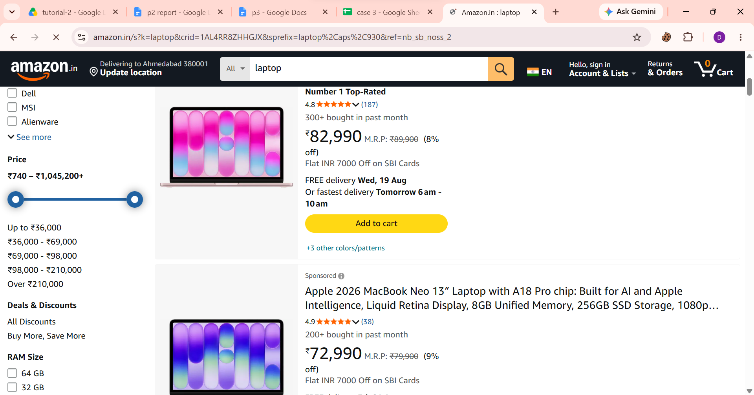

- Scenario ID: 1e
- Scenario: Select product
Test step:
- Open the selected product.
- Check product name.
- Check product image.
- Check product price.
- Check product description.
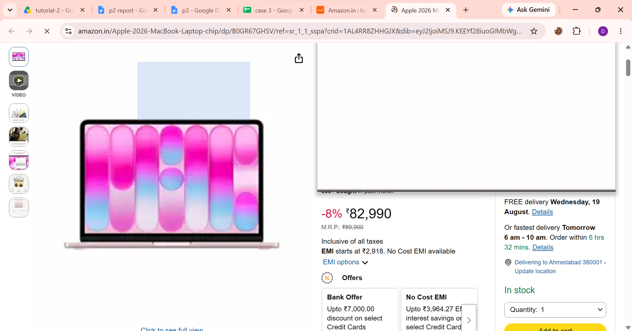
- Check product availability.

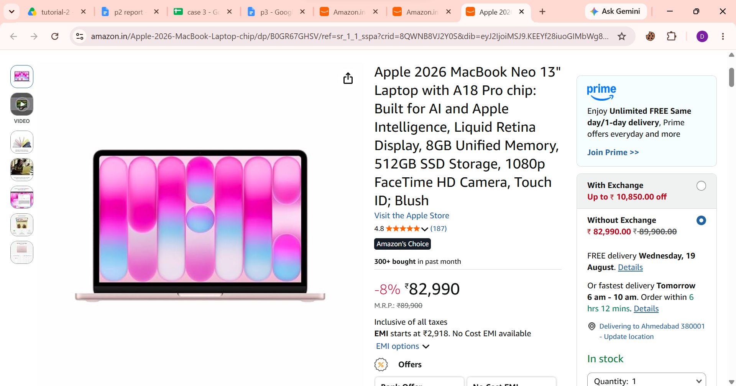

- Scenario ID: 1f
- Scenario: Add product to cart
Test step:
- Open a product.
- Select quantity if required.
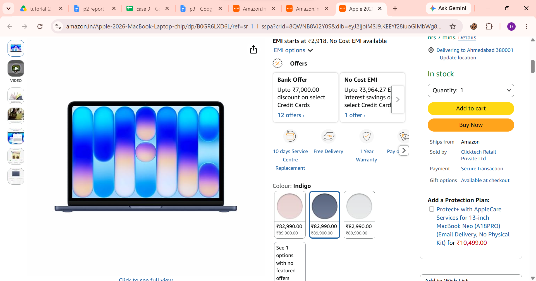
- Click Add to Cart.

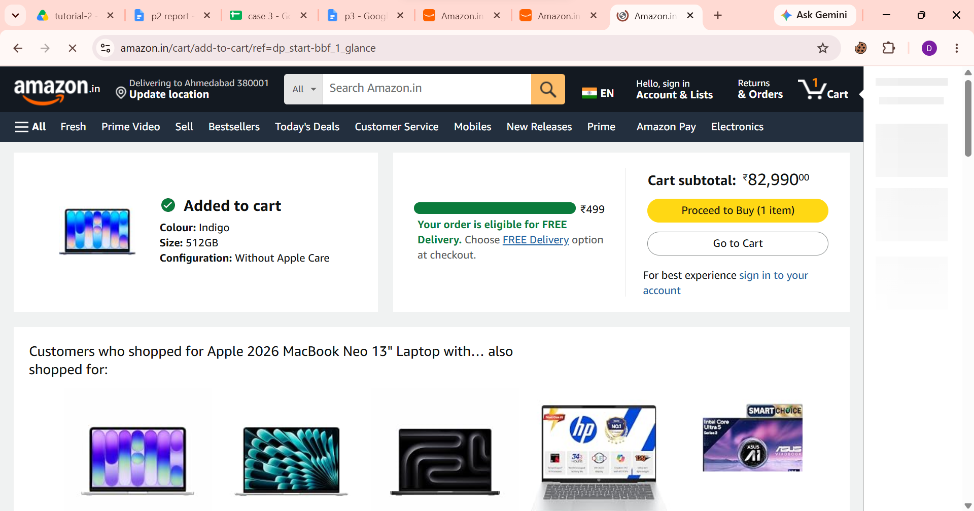

- Scenario ID: 1g
- Scenario: Open cart
Test step:
- Add a product to cart.
- Click the Cart icon.

- Scenario ID: 1h
- Scenario: Verify product in cart
Test step:
- Open Cart.
- Check product name.
- Check quantity.
- Check price.
- Compare with the originally selected product.
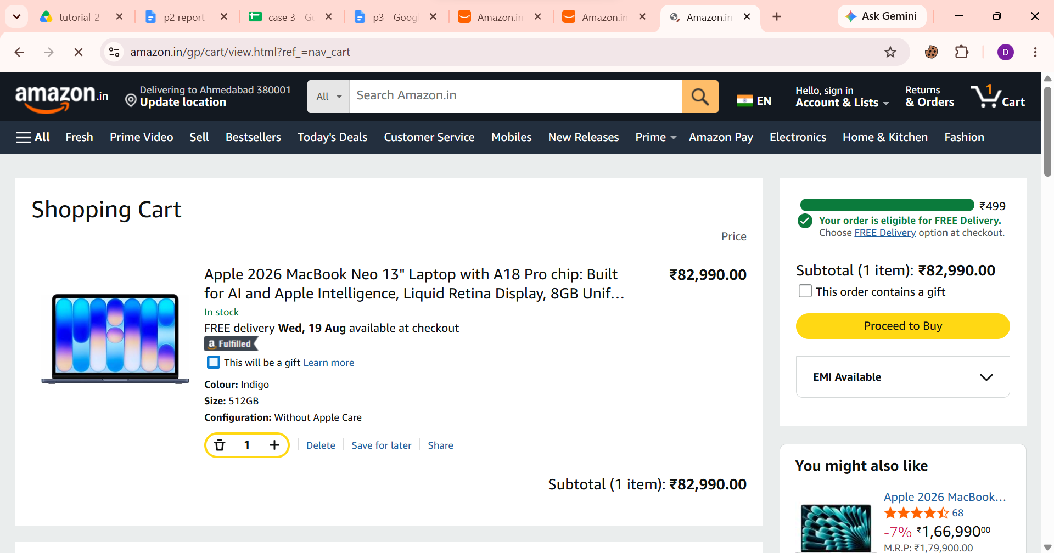
- Scenario ID: 1i
- Scenario: Remove product
Test step:
- Open Cart.
- Locate the added product.
- Click Delete.

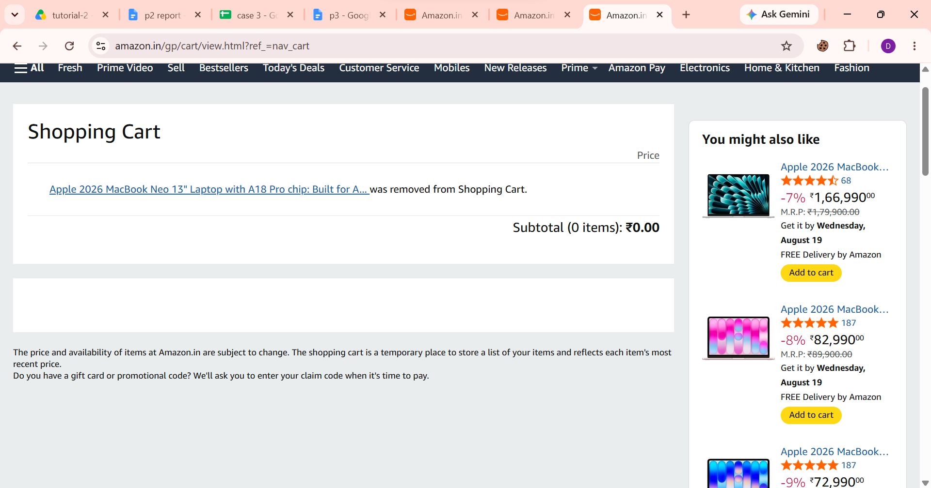

- Scenario ID: 1j
- Scenario: Logout
Test step:

- Click on the Account &
- Lists menu and select the
- Sign Out option.

